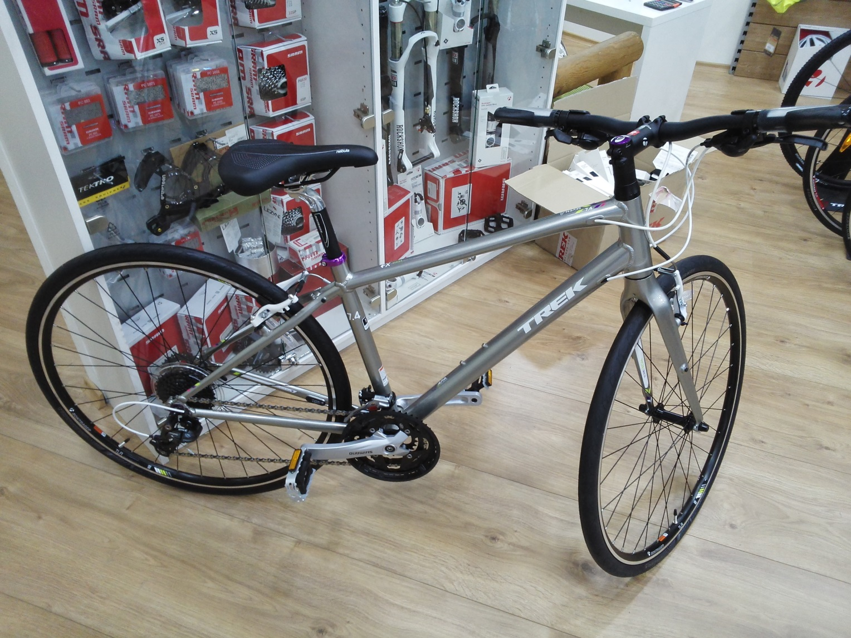
TREK 7.4 FX WSD
Colours: Platinum
Frame: WSD FX Alpha Gold Aluminium, DuoTrap S compatible, rack & mudguard mounts
Fork: Bontrager Nebula, carbon
Size: 17
Front hub: Formula TK31 alloy
Rear hub: Shimano FH-TX800
Rims: Bontrager Tubeless Ready
Tyres: back - Bontrager AW1 Hard-Case Lite, 700x32c;
front – Maxxis Overdrive Maxxprotect 27 TPI - 700 х 40C
Shifters: Shimano Acera M390, 9-speed
Front derailleur: Shimano Acera
Rear derailleur: Shimano Deore
Crank: Shimano Acera M391, 48/36/26 w/chainguard
Cassette: Shimano HG200, 11-32, 9-speed
Pedals: Wellgo nylon body w/alloy cage
Chain: KMC X9
Saddle: Bontrager H1 WSD
Seatpost: Bontrager Nebula, 27.2mm, 20mm offset
Handlebar: Bontrager Satellite Plus IsoZone, 31.8mm, 15mm rise
Stem: Bontrager Blendr Elite, w/computer & light mounts, 31.8mm, 7-degree
Headset: VP Slimstak, sealed semi-cartridge bearings
Brakeset: Tektro alloy linear-pull
Grips: Bontrager Satellite IsoZone Plus, lock-on, ergonomic

